Question 1:

OnLoad:

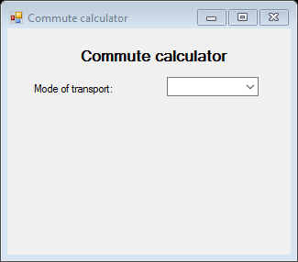

Selection Made(all fields populating):

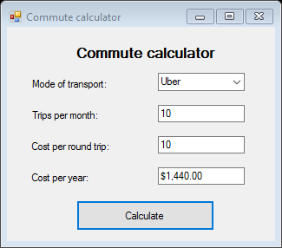

Form Validations:

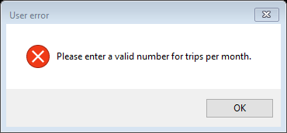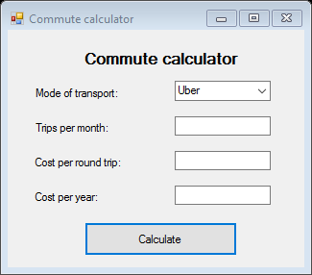

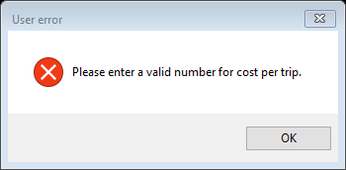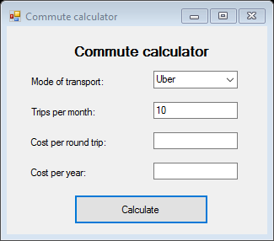

Source code:

Imports System.IO

Public Class frmCommuteCalculator

Dim fileName As String

Private Sub Form1_Load(sender As Object, e As EventArgs) Handles MyBase.Load

txtCostPerTrip.Hide()

txtCostPerYear.Hide()

txtTripsPerMonth.Hide()

lblCost.Hide()

lblTripsPM.Hide()

lblYearCost.Hide()

btnCalc.Hide()

fileName = "Cost.txt"

With cmbModeOfTransport.Items

.Add("Uber")

.Add("Subway")

.Add("Bus")

End With

End Sub

Private Sub cmbModeOfTransport_SelectedIndexChanged(sender As Object, e As EventArgs) Handles cmbModeOfTransport.SelectedIndexChanged

txtCostPerTrip.Show()

txtCostPerYear.Show()

txtTripsPerMonth.Show()

lblCost.Show()

lblTripsPM.Show()

lblYearCost.Show()

btnCalc.Show()

End Sub

Private Sub btnCalc_Click(sender As Object, e As EventArgs) Handles btnCalc.Click

Try

If txtTripsPerMonth.Text = "" Or (IsNumeric(txtTripsPerMonth.Text) = False) Then

MessageBox.Show("Please enter a valid number for trips per month.", "User error", MessageBoxButtons.OK, MessageBoxIcon.Error)

ElseIf Val(txtTripsPerMonth.Text) < 1 Then

MessageBox.Show("Please enter a valid number for trips per month.", "User error", MessageBoxButtons.OK, MessageBoxIcon.Error)

ElseIf txtCostPerTrip.Text = "" Or (IsNumeric(txtCostPerTrip.Text) = False) Then

MessageBox.Show("Please enter a valid number for cost per trip.", "User error", MessageBoxButtons.OK, MessageBoxIcon.Error)

ElseIf Val(txtCostPerTrip.Text) < 1 Then

MessageBox.Show("Please enter a valid number for cost per trip.", "User error", MessageBoxButtons.OK, MessageBoxIcon.Error)

Else

Dim obj_writer As New IO.StreamWriter(fileName, True)

Select Case cmbModeOfTransport.SelectedIndex

Case 0

txtCostPerYear.Text = (((Val(txtCostPerTrip.Text) * Val(txtTripsPerMonth.Text)) * 12) + (((Val(txtCostPerTrip.Text) * Val(txtTripsPerMonth.Text)) * 12) * 0.2)).ToString("C")

obj_writer.WriteLine("Mode of transport: " & cmbModeOfTransport.SelectedItem & vbNewLine & "Trips per Month: " & txtTripsPerMonth.Text & vbNewLine & "Cost per trip: R" & txtCostPerTrip.Text & vbNewLine & "Cost per year: " & txtCostPerYear.Text & vbNewLine)

obj_writer.Close()

Case 1

txtCostPerYear.Text = (((Val(txtCostPerTrip.Text) * Val(txtTripsPerMonth.Text)) * 12)).ToString("C")

obj_writer.WriteLine("Mode of transport: " & cmbModeOfTransport.SelectedItem & vbNewLine & "Trips per Month: " & txtTripsPerMonth.Text & vbNewLine & "Cost per trip: R" & txtCostPerTrip.Text & vbNewLine & "Cost per year: " & txtCostPerYear.Text & vbNewLine)

obj_writer.Close()

Case 2

txtCostPerYear.Text = (((Val(txtCostPerTrip.Text) * Val(txtTripsPerMonth.Text)) * 12)).ToString("C")

obj_writer.WriteLine("Mode of transport: " & cmbModeOfTransport.SelectedItem & vbNewLine & "Trips per Month: " & txtTripsPerMonth.Text & vbNewLine & "Cost per trip: R" & txtCostPerTrip.Text & vbNewLine & "Cost per year: " & txtCostPerYear.Text & vbNewLine)

obj_writer.Close()

End Select

End If

Catch ex As Exception

MsgBox(ex.ToString)

End Try

End Sub

End Class

Question 3:

Database for app:

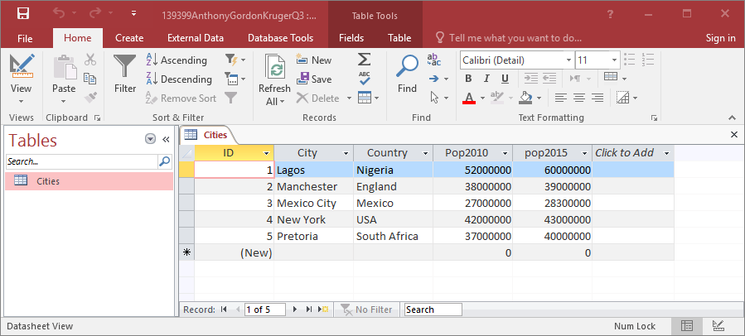

OnLoad(Connection established):

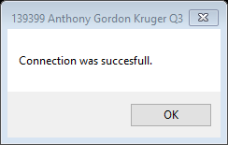

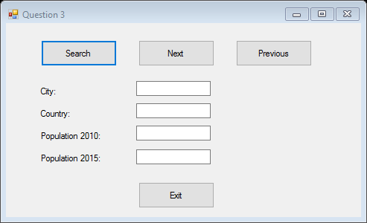

Search functionality (using name, all other fields can also be used):

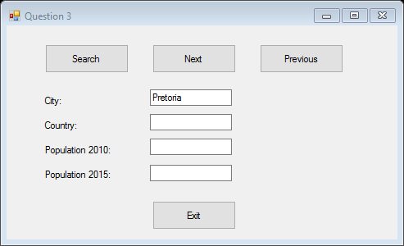

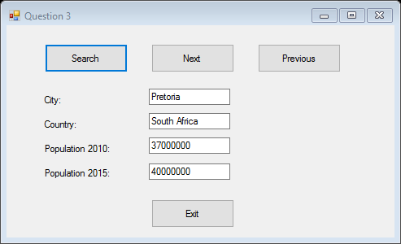

Previous button being pressed:

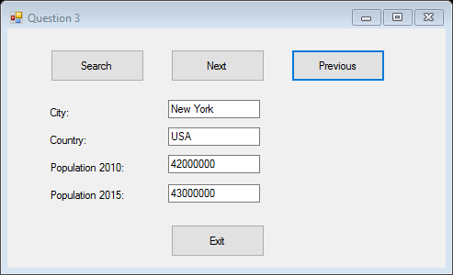

Next button pressed:

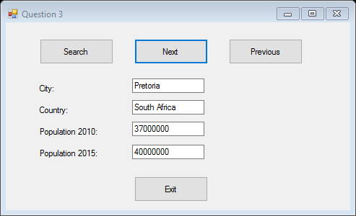

Source code:

Imports System.Data.OleDb

Public Class Form1

Dim source, provider, sqlStr, tableName As String

Dim obj_DS As New DataSet

Dim obj_Con As New OleDbConnection

Dim obj_DA As OleDbDataAdapter

Dim recordCount, incrementer As Integer

Private Sub btnExit_Click(sender As Object, e As EventArgs) Handles btnExit.Click

Application.Exit()

End Sub

Private Sub Form1_Load(sender As Object, e As EventArgs) Handles MyBase.Load

incrementer = -1

tableName = "Cities"

source = "DATA SOURCE=C:\Users\STUDENTS\Desktop\139399 Anthony Gordon Kruger Programming 512 exam\139399 Anthony Gordon Kruger Q3\139399 Anthony Gordon Kruger Q3\139399AnthonyGordonKrugerQ3.mdb"

provider = "PROVIDER=Microsoft.JET.OLEDB.4.0;"

sqlStr = "SELECT * FROM Cities"

obj_Con.ConnectionString = provider & source

Try

obj_Con.Open()

obj_DA = New OleDbDataAdapter(sqlStr, obj_Con)

obj_DA.Fill(obj_DS, tableName)

obj_Con.Close()

MsgBox("Connection was succesfull.")

recordCount = obj_DS.Tables(tableName).Rows.Count()

Catch ex As Exception

MsgBox(ex.ToString)

End Try

End Sub

Private Sub btnSearch_Click(sender As Object, e As EventArgs) Handles btnSearch.Click

Try

For i = 0 To recordCount - 1

If obj_DS.Tables(tableName).Rows(i).Item("City") = txtCity.Text Then

txtCountry.Text = obj_DS.Tables(tableName).Rows(i).Item("Country")

txtPop2010.Text = obj_DS.Tables(tableName).Rows(i).Item("Pop2010")

txtPop2015.Text = obj_DS.Tables(tableName).Rows(i).Item("Pop2015")

incrementer = i

ElseIf obj_DS.Tables(tableName).Rows(i).Item("Country") = txtCountry.Text Then

txtCity.Text = obj_DS.Tables(tableName).Rows(i).Item("City")

txtPop2010.Text = obj_DS.Tables(tableName).Rows(i).Item("Pop2010")

txtPop2015.Text = obj_DS.Tables(tableName).Rows(i).Item("Pop2015")

incrementer = i

ElseIf IsNumeric(txtPop2010.Text) Then

If obj_DS.Tables(tableName).Rows(i).Item("Pop2010") = txtPop2010.Text Then

txtCity.Text = obj_DS.Tables(tableName).Rows(i).Item("City")

txtCountry.Text = obj_DS.Tables(tableName).Rows(i).Item("Country")

txtPop2015.Text = obj_DS.Tables(tableName).Rows(i).Item("Pop2015")

incrementer = i

End If

ElseIf IsNumeric(lblPop2015.Text) Then

If obj_DS.Tables(tableName).Rows(i).Item("Pop2015") = lblPop2015.Text Then

txtCity.Text = obj_DS.Tables(tableName).Rows(i).Item("City")

txtPop2010.Text = obj_DS.Tables(tableName).Rows(i).Item("Pop2010")

txtCountry.Text = obj_DS.Tables(tableName).Rows(i).Item("Country")

incrementer = i

End If

End If

Next

Catch ex As Exception

MsgBox(ex.ToString)

End Try

End Sub

Private Sub btnNext_Click(sender As Object, e As EventArgs) Handles btnNext.Click

If incrementer < recordCount - 1 Then

incrementer += 1

txtCity.Text = obj_DS.Tables(tableName).Rows(incrementer).Item("City")

txtCountry.Text = obj_DS.Tables(tableName).Rows(incrementer).Item("Country")

txtPop2010.Text = obj_DS.Tables(tableName).Rows(incrementer).Item("Pop2010")

txtPop2015.Text = obj_DS.Tables(tableName).Rows(incrementer).Item("Pop2015")

Else

MsgBox("You are already at the last record.")

End If

End Sub

Private Sub btnPrevious_Click(sender As Object, e As EventArgs) Handles btnPrevious.Click

If incrementer >= 1 Then

incrementer -= 1

txtCity.Text = obj_DS.Tables(tableName).Rows(incrementer).Item("City")

txtCountry.Text = obj_DS.Tables(tableName).Rows(incrementer).Item("Country")

txtPop2010.Text = obj_DS.Tables(tableName).Rows(incrementer).Item("Pop2010")

txtPop2015.Text = obj_DS.Tables(tableName).Rows(incrementer).Item("Pop2015")

Else

MsgBox("You are already at the first record.")

End If

End Sub

End Class

Question 4:

Validation check for file:

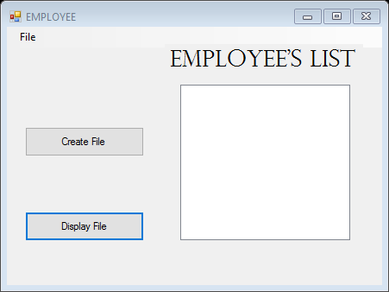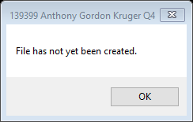

File successfully being written:

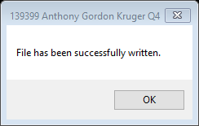

File successfully displayed

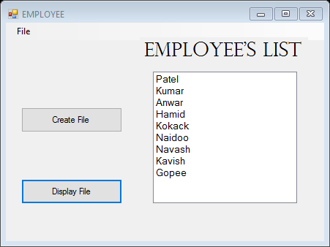

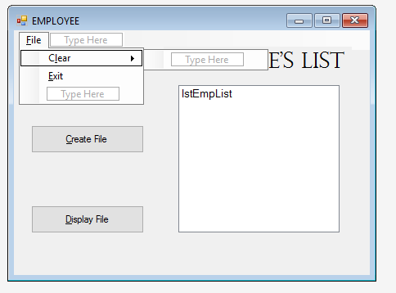

All fields and files successfully cleared:



Sample of file:

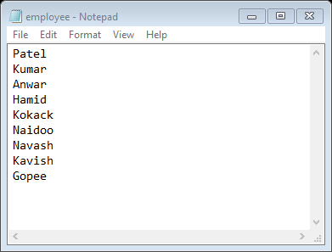

Source Code:

Imports System.IO

Public Class frmEmp

Dim fileName, empNames(8) As String

Private Sub frmEmp_Load(sender As Object, e As EventArgs) Handles MyBase.Load

empNames(0) = "Patel"

empNames(1) = "Kumar"

empNames(2) = "Anwar"

empNames(3) = "Hamid"

empNames(4) = "Kokack"

empNames(5) = "Naidoo"

empNames(6) = "Navash"

empNames(7) = "Kavish"

empNames(8) = "Gopee"

fileName = "employee.txt"

End Sub

Private Sub btnCreate_Click(sender As Object, e As EventArgs) Handles btnCreate.Click

Try

Dim ObjWriter As New StreamWriter(fileName)

For i = 0 To empNames.Length - 1

ObjWriter.WriteLine(empNames(i))

Next

ObjWriter.Close()

MsgBox("File has been successfully written.")

Catch ex As Exception

MsgBox(ex.ToString)

End Try

End Sub

Private Sub btnDisplay_Click(sender As Object, e As EventArgs) Handles btnDisplay.Click

Try

If File.Exists(fileName) Then

Dim objReader As New StreamReader(fileName)

While objReader.Peek <> -1

lstEmpList.Items.Add(objReader.ReadLine())

End While

objReader.Close()

MsgBox("File has been successfully read and displayed.")

Else

MsgBox("File has not yet been created.")

End If

Catch ex As Exception

MsgBox(ex.ToString)

End Try

End Sub

Private Sub ClearToolStripMenuItem_Click(sender As Object, e As EventArgs) Handles ClearToolStripMenuItem.Click

lstEmpList.Items.Clear()

'The following code is to create a new text file with no contents and overwrite to create the effect of the file being cleared

Try

Dim ObjWriter As New StreamWriter(fileName)

ObjWriter.WriteLine("")

ObjWriter.Close()

MsgBox("File has been successfully been cleared.")

Catch ex As Exception

MsgBox(ex.ToString)

End Try

End Sub

Private Sub ExitToolStripMenuItem_Click(sender As Object, e As EventArgs) Handles ExitToolStripMenuItem.Click

Application.Exit()

End Sub

End Class